CONTENTS

- ABSTRACT
- INTRODUCTION
- SOFTWARE REWUIREMENTS
- HARDWARE REQUIREMENTS
- ER- diagrams
- REFERENCES

ABSTRACT

Online Food Ordering System is a part of e-commerce. E-commerce or business through net means distributing, buying, selling, marketing, and servicing of products or services over electronic systems such as the Internet and other computer networks. Thus if we own a restaurant we need to upload menu online to attract potential customers.

The online food ordering system gives restaurants the ability to increase
sales and expand their business by giving customers the facility to order food online.
With an online restaurant menu ordering system, customers can place orders online 24 *7. Thus it is a simple, fast and convenient food ordering system giving an edge over the competition at an affordable price.

Internet has seen a tremendous growth in terms of coverage and awareness.
So giving the business an online presence has become very crucial and important.
With [Online Ordering System], we can set up we restaurant menu online and the customers can easily place order with a simple mouse click. Also with a food menu online we can easily track the orders, maintain customer's database and improve the food delivery service. We can receive order through e-mails/ fax or directly view on internet.

The restaurants’ can even customize online restaurant menu and upload images easily. Having restaurant menu on internet, potential customers can easily access it and place order at their convenience..

INTRODUCTION

An online food ordering system is a web-based application that stimulates the foodies (customers) to put food orders through internet by locating their favorite restaurant or nearest one. This application is based on the asp.net platform .

OBJECTIVE:-
The main objective of this project is to develop an application which gives provision to the restaurant owners to flourish their business by uploading menus at no cost and will invariably lead to higher customer retention and acquisition rates.

FEATURES:-
- Online menus (original and searchable format)
- Provision of restaurant owners to register themselves with their menu.
- Easy lookup of restaurants in your area
- Check Ratings and Review the restaurants
- Simple, fast and convenient ordering of food
- Availability of the menu online 24*7*365 – no need to recite the complete menu over the phone. An online menu is ready to be viewed and printed by people worldwide.
- Accurate – no more spelling out the dishes’ names.
- Menu with the actual pictures of the product thereby adding to the uniqueness of your online presence.
- Prior knowledge of time for delivery helps prepare and provide better service.
- Provides base for online promotions, electronic coupons and gift certificates without needing the costly conventional media.
- Receive direct customer feedback and suggestions.
- Keep the customers informed.

ADVANTAGES:-
- Reduce time-consuming phone orders and eliminate illegible fax orders.
- No more busy phones or the requirement for extra phone lines.
- An edge over the competition at an affordable price.
- Broader customer reach across regions.
- Builds a customer database.
- Provides a channel for marketing and promotion lowering your advertising cost.
- Helps in improved service.
- Greater customer satisfaction!!!

SYSTEM Requirements

- SOFTWARE REQUIREMENTS

- Operating system
- Windows 2000/Professional/XP
- Front-end
- Python 3, Django Framework
- Back-end
- My Sql

- HARDWARE REQUIREMENTS

Processor | 450 MHz Pentium II-class processor  600MHz Pentium III-class or IV processor
Operating system | Standard editions can be installed on any of the following systems:-  - Microsft windows server 2003  - Windows XP Home edition
Memory | 512MB for both Microsoft windows server 2003 and Windows XP Home edition
Hard Disk | Minimum space required to install .NET=3.5GB  Minimum space required to install SQL SERVER=1.6GB

The Data Flow Diagram of
the Food Ordering System:

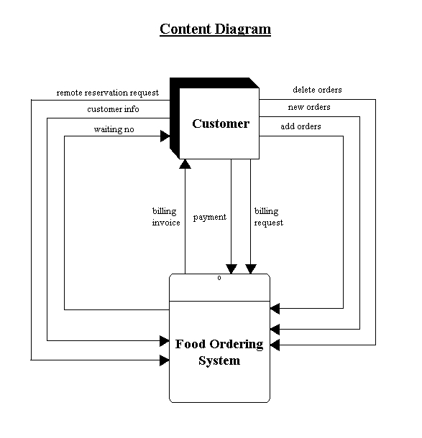

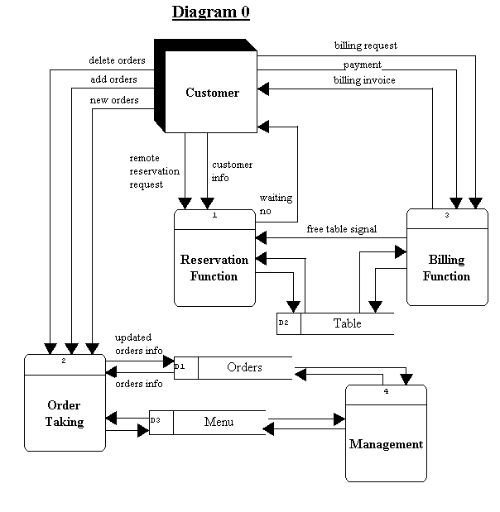

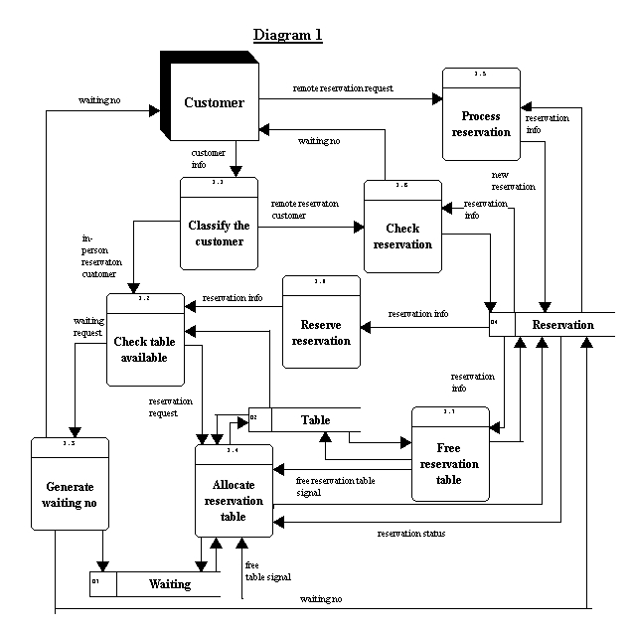

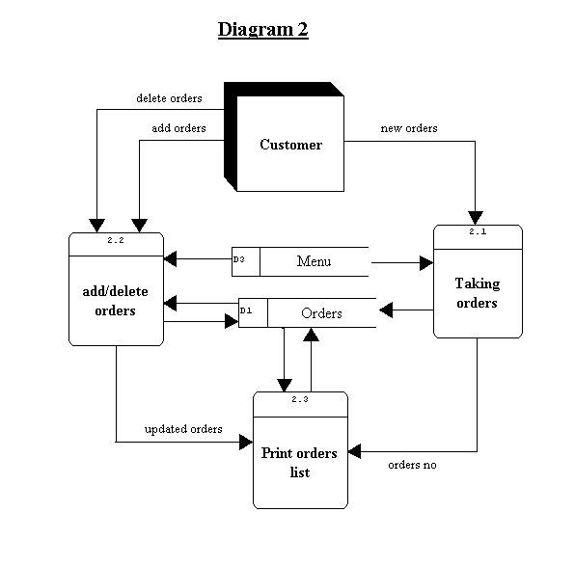

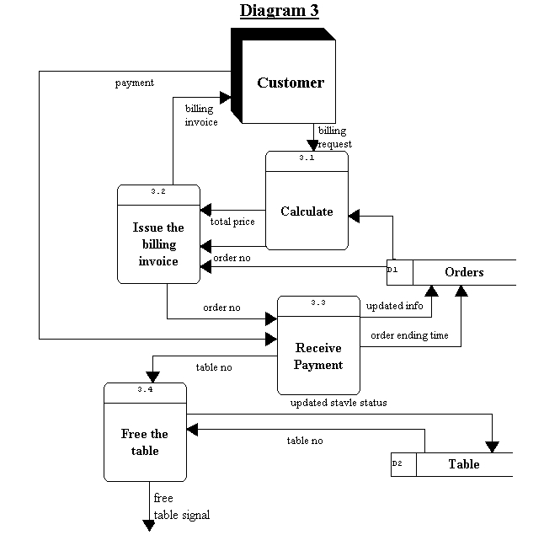

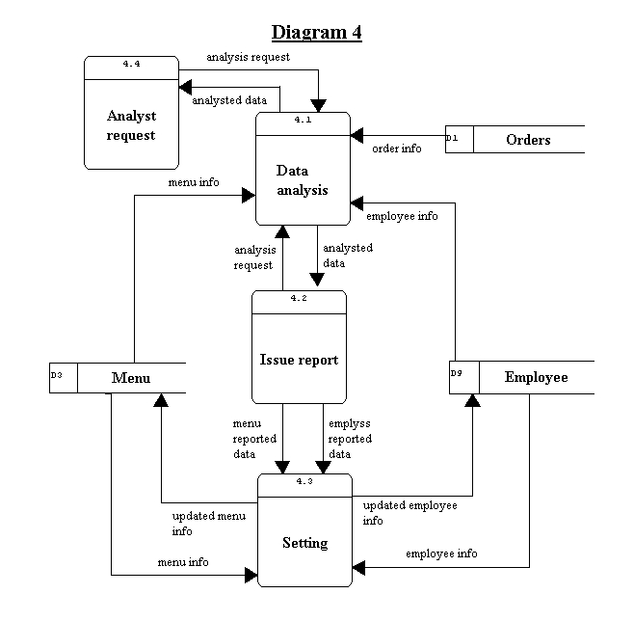

The structure Diagram of Food Ordering System
0
Food Ordering System

4
Management

4.4
Analyst request

4.3
Setting

4.2
Report processor

4.1
Data analysis

2
Ordering Taking

1
Reservation Function

2.1
Taking orders
2.2
Add/delete orders

2.3
Print order list

1.4
Allocate reservation table

1.3
Generate waiting no.

1.2
Check table available

1.1
Classify customer
1.7
Free reservation table

1.6
Check reservation

1.5
Process reservation

1.8
Process reservation

3
Billing Function

3.3
Receive Payment

3.2
Issue the billing invoice

3.1
Calculate

3.4
Free the table

The Entity-Relationship Diagram

Table

Employee

Waiting

Reservation

Performance

Orders

Menu

Orderline

The Database Design of the Food Ordering System

Format of the database

Orders (D1)

Field name | Brief Description | Field type | Restriction
Order_no | Order number (KEY FIELD) | Integer (6) | 1-999999
Table_no | Table number | Integer (2) | 1-99
Order_time | Order time | Time | -----
Order_date | Order date | Date | -----
Head_no | Head number | Integer (2) | 1-20
Payment_status | Status of payment | Boolean | True,False
* N = Not Done, P = Processing, F = finished, D = Delivered

Orderline

Field name | Brief Description | Field type | Restriction
Order_no | Order number | Integer (6) | 1-999999
Item_no | Item number | Integer (3) | 1-999
Quantity | Quantity of the item | Integer (2) | 1-99

Table (D2)

Field name | Brief Description | Field type | Restriction
Table_no | Table number (KEY FIELD) | Integer (2) | 1-99
Status | Status of the table | Character | R, I, F
* R = Reservation, I = In-use, F = Free

Menu (D3)

Field name | Brief Description | Field type | Restriction
Item_no | Item number (KEY FIELD) | Integer (3) | 1-999
Item_price | Item price | Currency | $1-999
Item_name | The name of Item | String(20) | 1-20char
Status | Status of the item | String(2) | BX, LX, DX, PX
Discount | Discount value | Percentage | 0%-100%
Photo | Photo of the item | Object | -----
Description | Description of the item | String (40) | 1-40 char
* B = Breakfast, L = Lunch, D = Dinner, P = Promotion,X=A,B,C,D or X

Reservation (D4)

Field name | Brief Description | Field type | Restriction
Res_no | Reservation number (KEY FIELD) | Integer (3) | 1-999
Date | Reservation date | Date | -----
Time | Reservation time | Time | -----
Cus_info | Customer name | String (20) | 1-20 char
Tel | Telephone number | Integer (8) | 8 digits
Head_no | Head number | Integer (2) | 1-20
Table_no | Table number | Integer (2) | 1-99
Waiting_no | Waiting number | Integer (3) | 1-999
Status | Status of reservation | Character | N, T, U, C, W
* N = Normal, T = Tabled, U = Un-reserved, C = Cancel, W = Waiting

Waiting (D5)

Field name | Brief Description | Field type | Restriction
Waiting_no | Waiting number (KEY FIELD) | Integer (3) | 1-999
Priority | Priority (Walk-in, Reservation) | Character | W, R
Status | Status of the waiting number | Character | D, S
W = Walk-in, R = Reservation, D = Done, S = Still waiting

Employee (D6)

Field name | Brief Description | Field type | Restriction
Employee_no | Employee number (KEY FIELD) | Integer (2) | 1-99
Name | Employee name | String (20) | 1-20 char
Tel | Employee telephone number | Integer | 8 digits
Address | Employee address | String (60) | 1-60 char
Position | Position of the employee | String (20) | 1-20 char
Work_in_time | Start work time | Time | -----
Work_out_time | End work time | Time | -----
Day_off | Day off | Integer (1) | 1-7
Salary | Salary of the employee | Currency | $1-99999

Relational Schema

Table (Table_no, Status)

Order (Order_no, Table_no, Order_time, Order_date, Head_no, Payment_status)

Orderline (Order_no, Item_no, quantity)

Menu (Item_no, ,Item_name, Item_price, Status, Discount, Photo, Description)

Reservation (Res_no, Date, Time, Cus_info, Tel, Table_no, Waiting_no, Status, Head_no)

Waiting (Waiting_no, Priority, Status)

Employee (Employee_no, Position, Work_in_time, Work_out_time, Employee_name, Tel, Address, Salary, Dayoff)

Performance (Employee_no, Order_no, Attitude, Efficiency, Polite, Satisfaction)

Referrences

- Books:-
- Programming in C#, E BALAGURUSWAMI
- ASP.NET 2.0, Black Book
- The complete reference in SQL Server 2000,TMH

- WebSites:-
- www.google.com
- www.w3school.com

